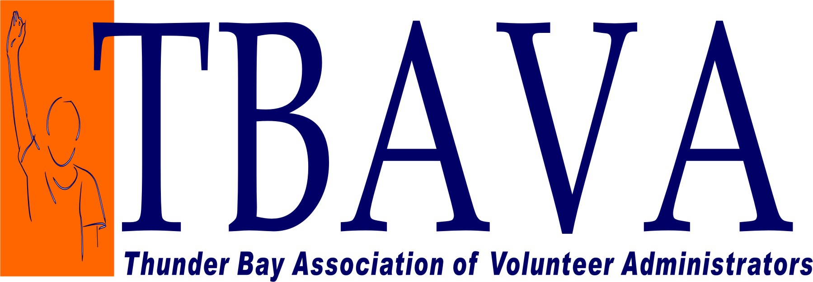

Proudly Presents

“Managing Risk: Balancing Aversion & Innovation”

Conference Video

It’s like TED Talks meets late night talk show

Wednesday October 21, 2020
9:30am - 3:30pm
Hosted virtually

Hosted by Faiza Venzant, CVA

Presentation Team:

Lindsay Baker, CVA
“Taking Smart Risks and Piloting Innovation”

Lori Gotlieb
“Safe and Sound: Volunteer Management Check Up For Your Volunteer Program”

Jennifer Bennett, CVA
“Is Soft Risk Hiding in Your Volunteer Engagement Strategy?”

Sarah Olivieri
“Managing Risk through Program Design”

Space is limited to 30 registrants…so register early to guarantee participation.

Name: ___________________________________________ Organization: ________________________________________

Address: ______________________________ Phone Number / E-mail:____________________/_______________________

Please circle one:
A. TBAVA member…….…………. $ 75.00
B. Non-Member …………………. $ 150.00
________________________________________________________________________________________

Complete registration form & forward together with payment, no later than October 14th, 2020 to:

TBAVA Workshop 2020 - Hybrid Conference
c/o Charmaine Cades at Children’s Aid Society
1110 Jade Court
Thunder Bay, ON P7B 6M7

Cheques payable to: “TBAVA”
For more information contact:
Charmaine Cades, TBAVA Membership/Registrar
Phone: (807) 343-6192
E-mail: charmaine.cades@thunderbaycas.ca

To see speaker and workshop session overviews visit:

Hybrid Workshop Video https://vimeo.com/440454562

